**EX.NO:11**

**DATE:**

**PROGRAM:** Simulate the Circular Reference for the given data.

**AIM:**

To simulate the circular reference for the given data using array concepts in excel.

**ALGORITHM:**

**STEP: 1**

Open MS-EXCEL by using the command start- all programs- Microsoft office- MS-excel.

**STEP**: **2**

Feed the data into the worksheet.

**STEP: 3**

To find other expenses, type formula as =C9*0.1

**STEP: 4**

To find profit, type formula as =C5-C6-C7-C8

**STEP: 5**

Open File – options – Formulas – Enable iterative calculation, to enable circular reference

**OUTPUT:**

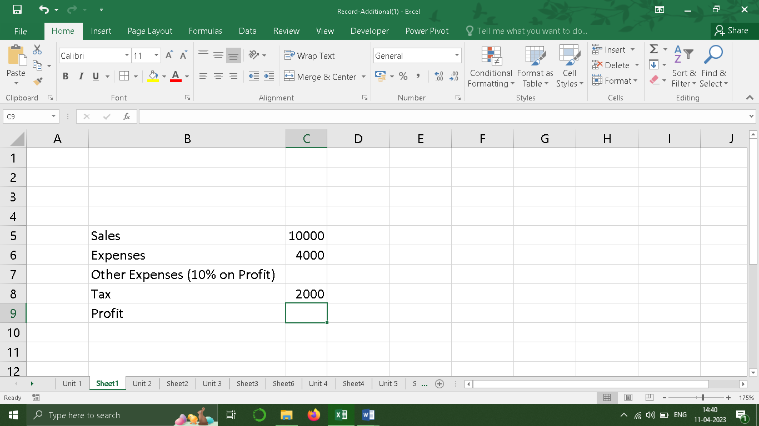

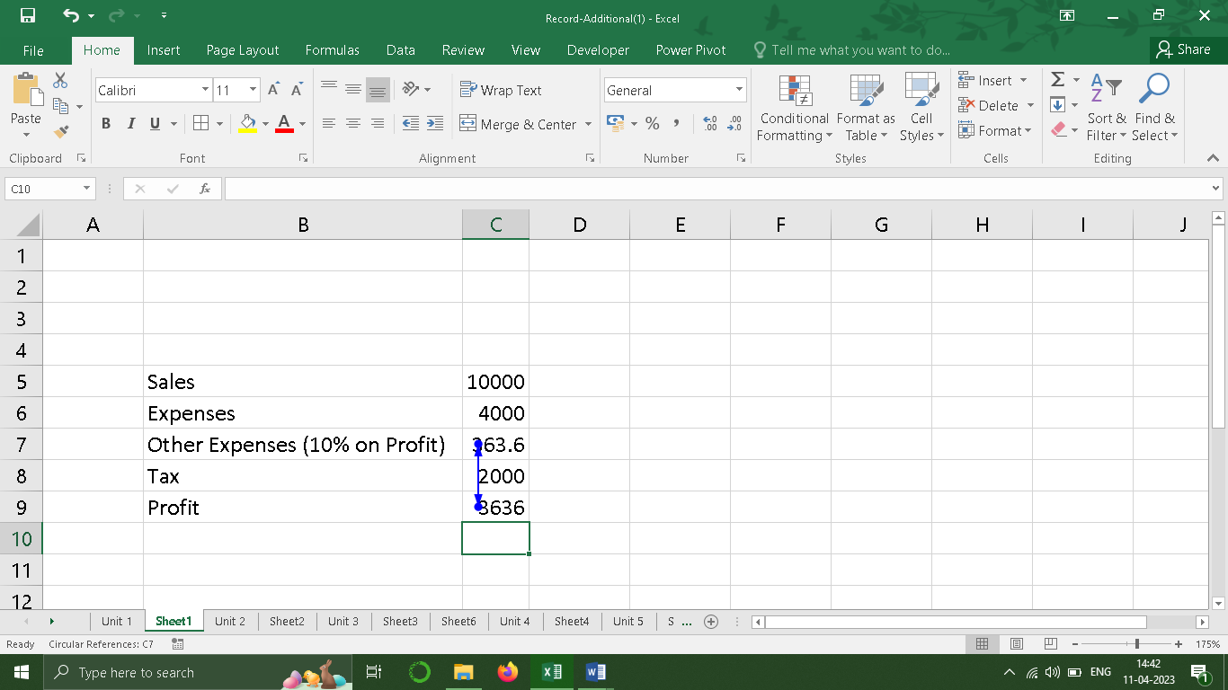

**RESULT:**

Now the desired output will be displayed

**EX.NO:12**

**DATE:**

**PROGRAM:**  Create a Dynamic Graph Control Chart for the following data

**AIM:**

To create a dynamic graph control chart for the given data in excel.

**ALGORITHM:**

**STEP: 1**

Open MS-EXCEL by using the command start- all programs- Microsoft office- MS-excel.

**STEP**: **2**

Feed the data into the worksheet.

**STEP: 3**

Insert a checkbox’s using developer option and link a cell’s to checkbox using format control option.

**STEP: 4**

Use if condition to link the values with checkboxes.

**STEP: 5**

Now insert a chart using, Insert menu

**STEP: 6**

Now change the profit into line chart using change chart type in Design menu

**OUTPUT:**

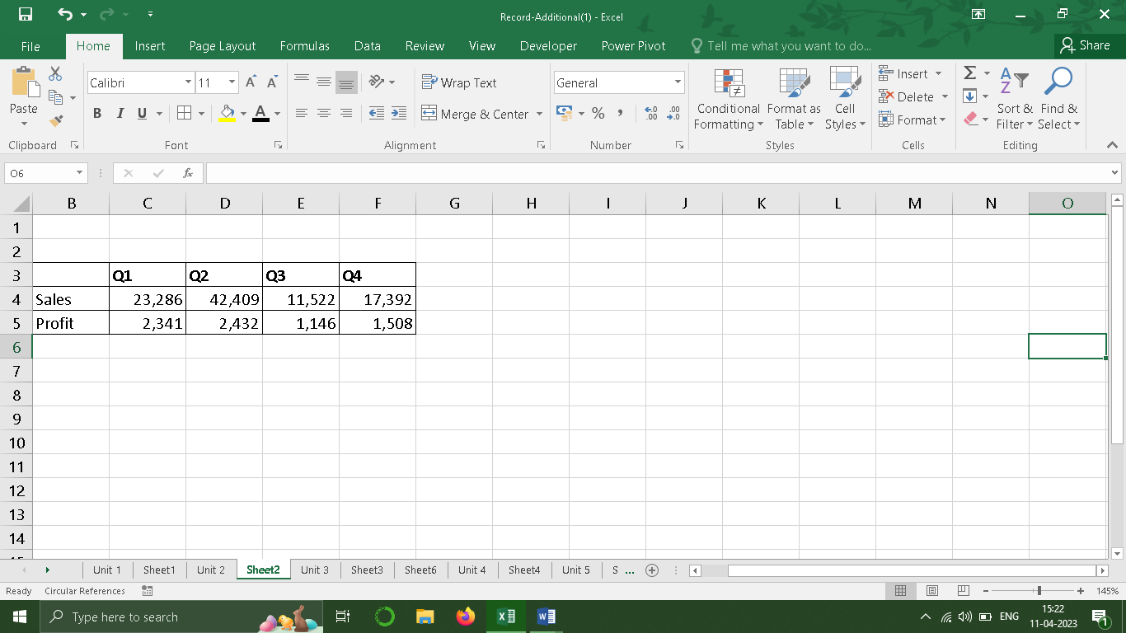

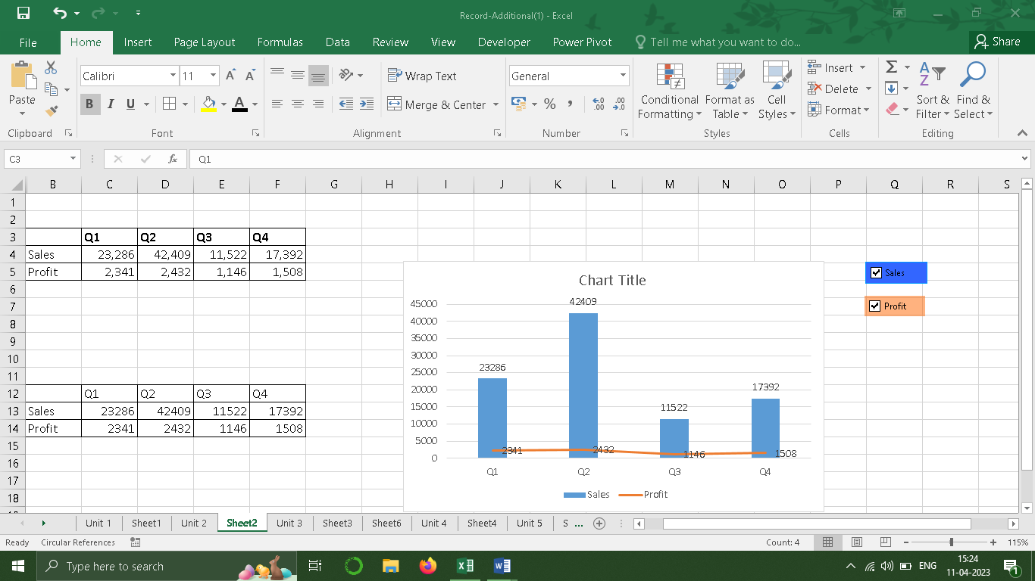

**RESULT:**

Now the desired output will be displayed

**EX.NO:13**

**DATE:**

**PROGRAM:**  Create a Dynamic Graph Control Chart for the following data

**AIM:**

To create a dynamic graph control chart for the given data in excel.

**ALGORITHM:**

**STEP: 1**

Open MS-EXCEL by using the command start- all programs- Microsoft office- MS-excel.

**STEP**: **2**

Feed the data into the worksheet.

**STEP: 3**

Insert a pivot box using Insert menu by selecting the data

**STEP: 4**

Now select the values using Pivot table field menu

**STEP: 5**

Now insert slicer using Analyze menu for company & variable fields

**STEP: 6**

Now move the slicers to a newsheet and create a table for each year separately

**STEP:7**

Now use the vlookup formula to get values from pivot table for each year

**STEP:8**

Now the desired output will be displayed

**OUTPUT:**

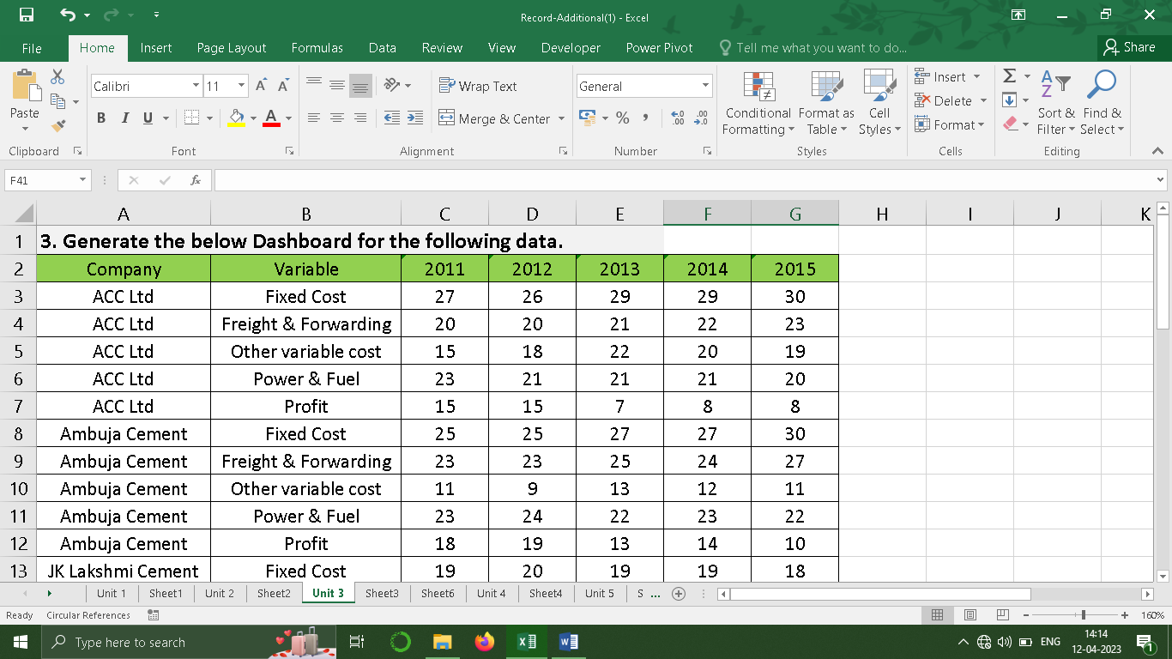

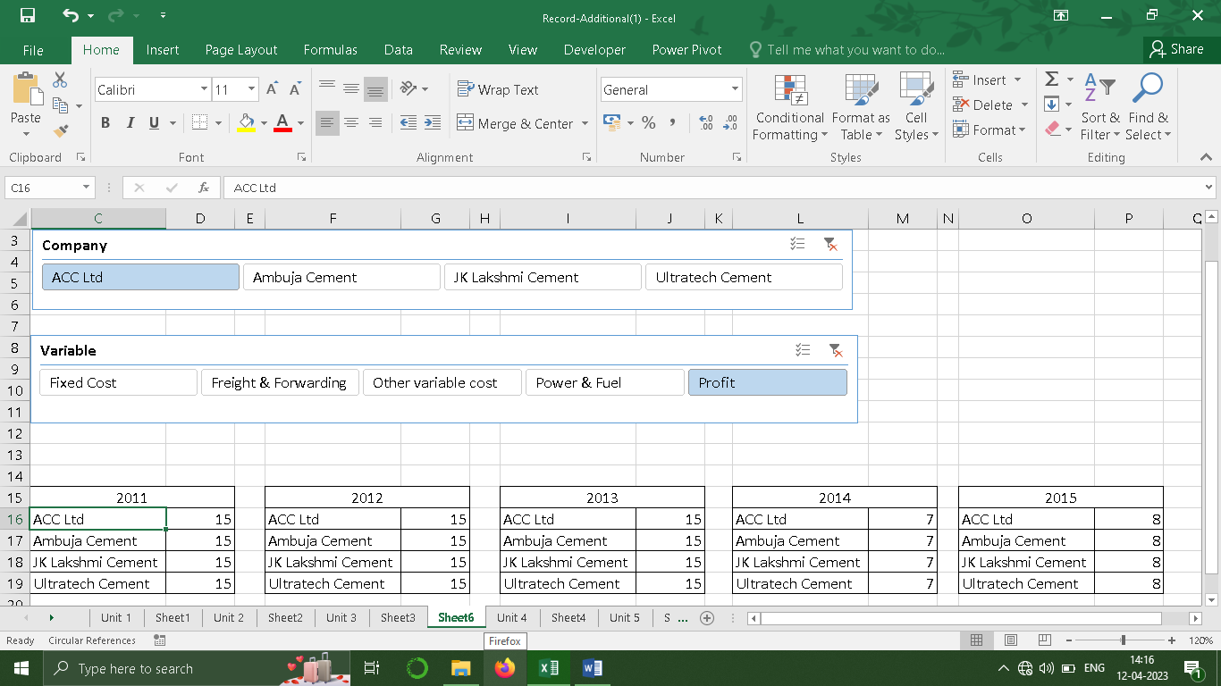

**RESULT:**

Now the desired output will be displayed

**EX.NO:14**

**DATE:**

**PROGRAM:**  Record a Macro for finding a given text in the list of strings

**AIM:**

To record a Macro for finding a given text in the list of stringsin excel.

**ALGORITHM:**

**STEP: 1**

Open MS-EXCEL by using the command start- all programs- Microsoft office- MS-excel.

**STEP**: **2**

Feed the data into the worksheet.

**STEP: 3**

**STEP: 4**

**STEP: 5**

**STEP: 6**

**STEP:7**

**OUTPUT:**

**RESULT:**

Now the desired output will be displayed

**EX.NO:15**

**DATE:**

**PROGRAM:** Calculate the Regression using Moving Average method for the below data

**AIM:**

To calculate the Regression using Moving Average method for the below data

**ALGORITHM:**

**STEP: 1**

Open MS-EXCEL by using the command start- all programs- Microsoft office- MS-excel.

**STEP**: **2**

Feed the data into the worksheet.

**STEP: 3**

**STEP: 4**

**STEP: 5**

**STEP: 6**

**STEP:7**

**OUTPUT:**

**RESULT:**

Now the desired output will be displayed